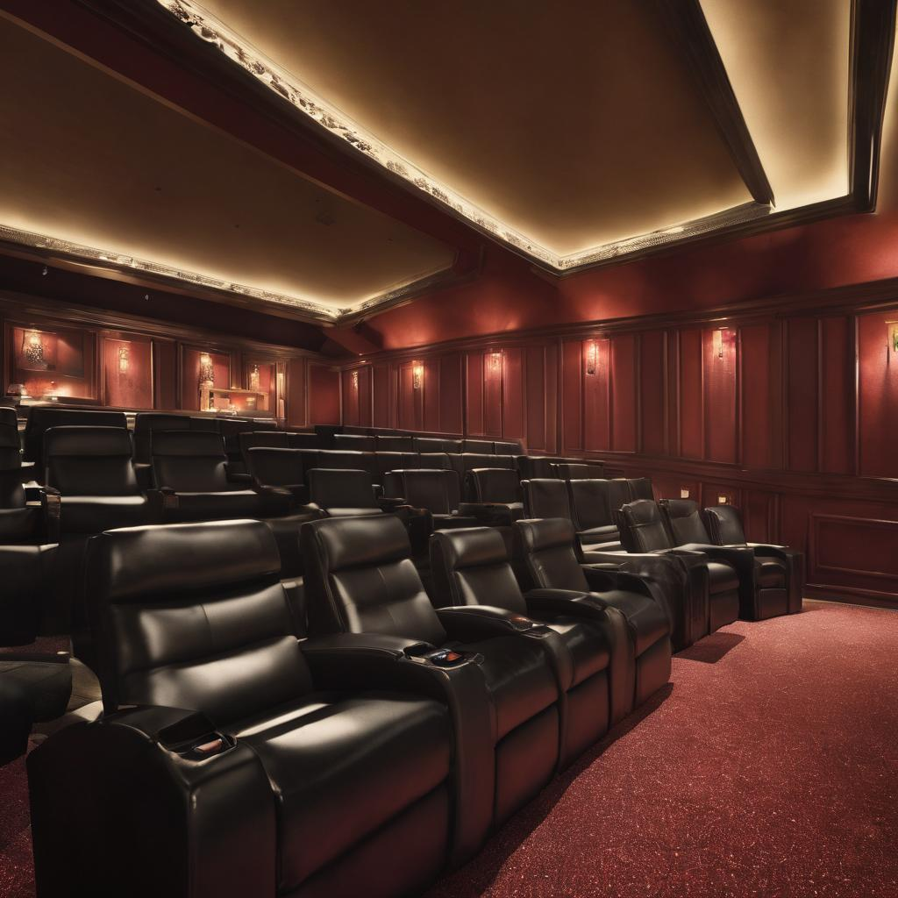

**Rexon Movie Theatre**

Contents

Table of Graphs: 3

1 DEFINE PHASE 4

1.1 Gender-Based Distribution: 5

1.2 Age-based Distribution 5

1.3 RMT Booking Pattern 9

1.4 Theater Experience 11

1.4.1 Theatre Hygiene experience 11

1.4.2 Theatre F and B Experience: 13

1.5 RMT Staff Performance 14

1.6 Project Charter Document 16

1.7 RACI Model 17

2 MEASURE PHASE 18

2.1 Fishbone diagram 18

2.2 Cinema viewers’ experience gander-based 19

2.3 Pareto chart 21

2.4 Show cancellation reasons 22

2.5 Cause and Effect Analysis 26

2.6 Pareto Chart 27

2.7 SIPOC 28

2.8 Cause and Effect Matrix 29

3 ANALYZE PHASE: 31

3.1 RMT Audi Temperature Hypothesis Testing 33

3.2 RMT Audi Recliner Tilt Hypothesis Testing 34

4 IMPROVE PHASE: 37

4.1 RMT Audi Temperature Optimality Analysis Hypothesis Testing 37

4.2 RMT Audi Recliner Tilt Goodness Analysis Hypothesis Testing 40

4.3 RMT Audi Temperature PRE and Post Improvement 41

4.4 RMT Viewers’ Theatre Experience 42

5 CONTROL PHASE: 44

5.1 Inferences: 44

5.2 Conclusion: 45

# Table of Graphs:

Graph 1: Age-based distribution BMR 6

Graph 2: Age-based distribution RSVO 7

Graph 3: Booking pattern at RSVO 10

Graph 4: Booking pattern at BMR 10

Graph 5: Theatre Hygiene at RSVO 12

Graph 6: Theatre hygiene at BMR 12

Graph 7: Cinema experience at RMT 19

Graph 8: Pareto chart 21

Graph 9: Show cancellation reasons 22

Graph 10: Pareto chart 27

Graph 11: Air Conditioning after pilot test 42

Graph 12: Theatre experience after pilot test 43

# DEFINE PHASE

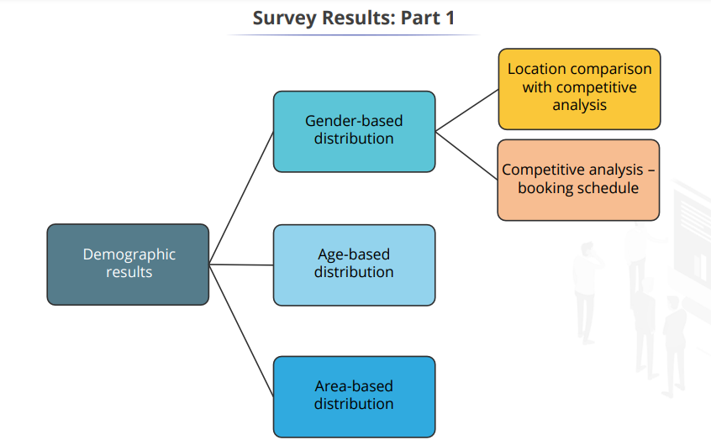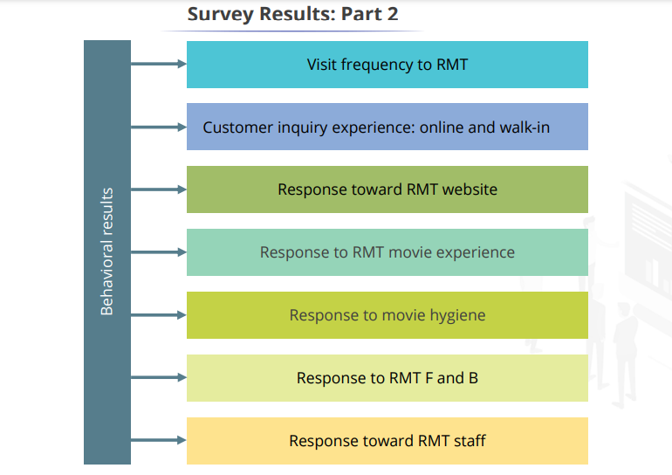

## Gender-Based Distribution:

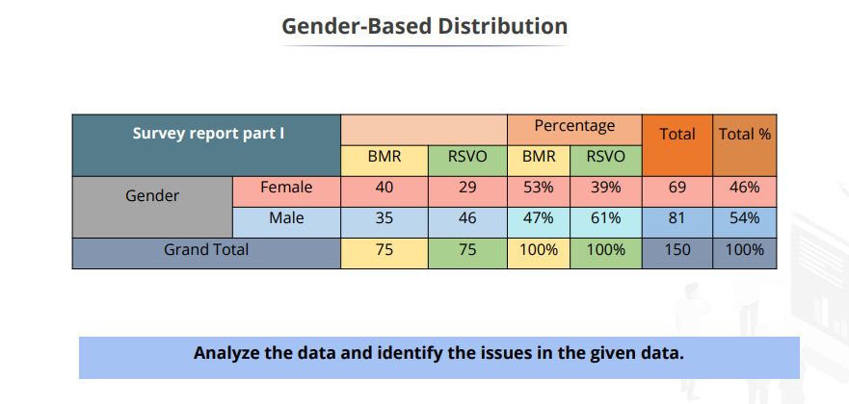

* **In RSVO, 61% of respondents are men.**
* **Less frequent female patrons in RSVO observed from a survey and security guard reaction**

|  |  |
| --- | --- |
| Inferences | |
| Largely, male members make purchase decisions at RSVO | Possible causes of female experience lacking at RSVO:   * Is safety a concern? * Is watching films a taboo for females? * Females did not answer to the poll. |

## Age-based Distribution

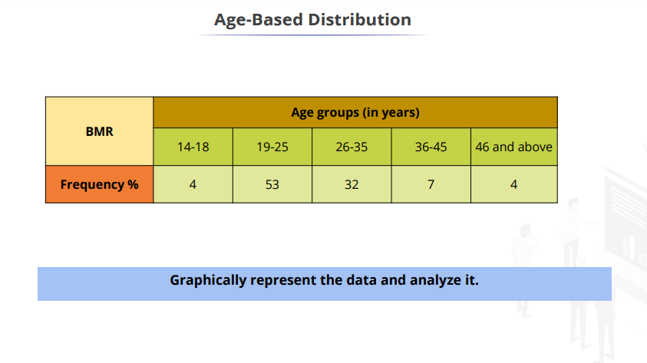

Graph : Age-based distribution BMR

|  |  |
| --- | --- |
| Inferences | |
| The largest respondents in BMR are in the 19-25 age bracket. | The food court on the floor below BMR offers a wide range of delicacies acting as a meeting hub for young couples |

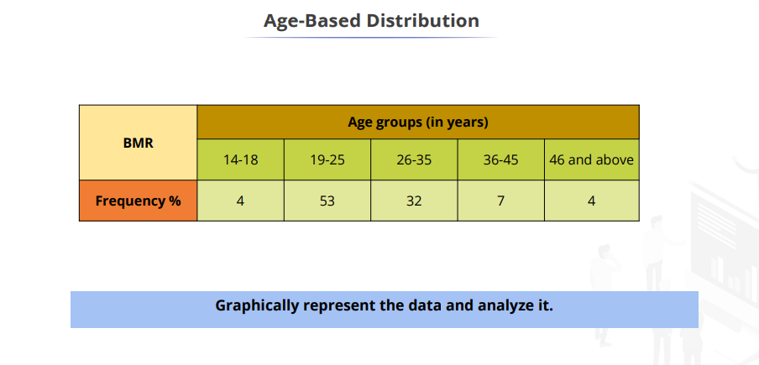

Graph : Age-based distribution RSVO

|  |  |
| --- | --- |
| Inferences | |
| Relatively even distribution of age groups at RSVO | Presence of Fusion multi-cuisine family restaurant |

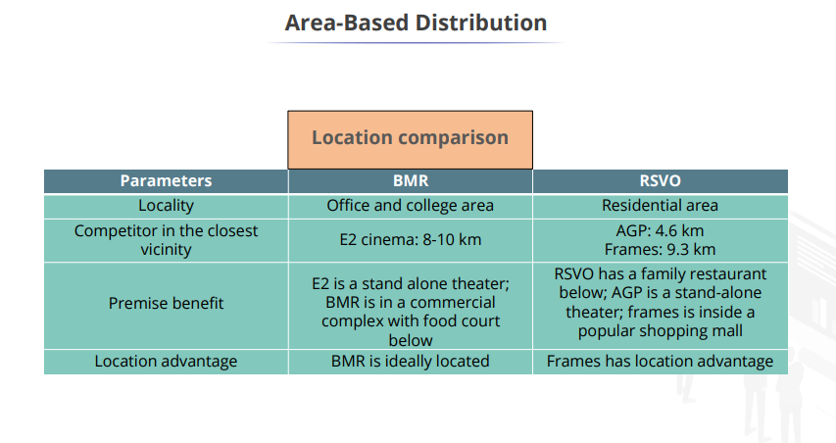

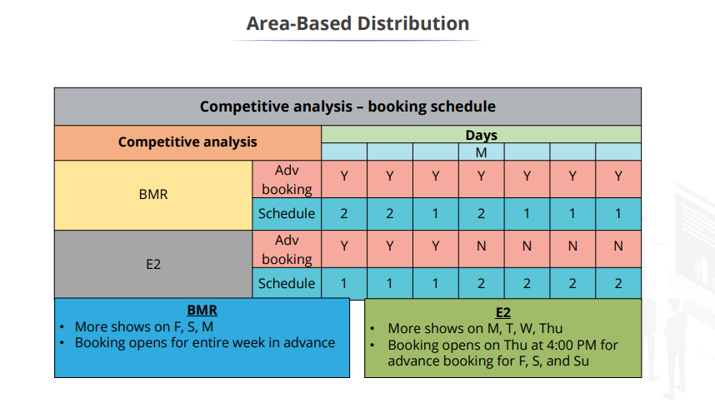

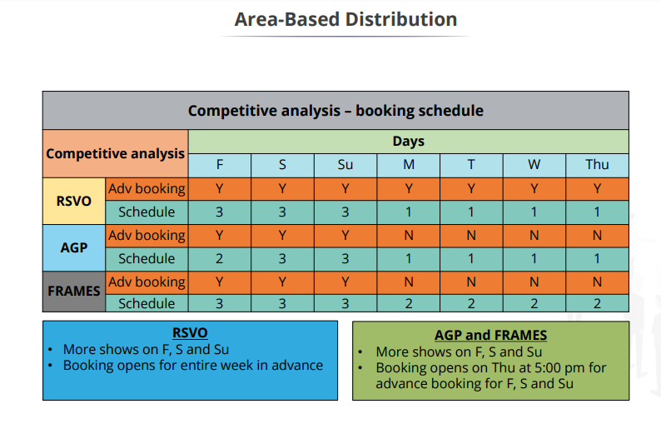

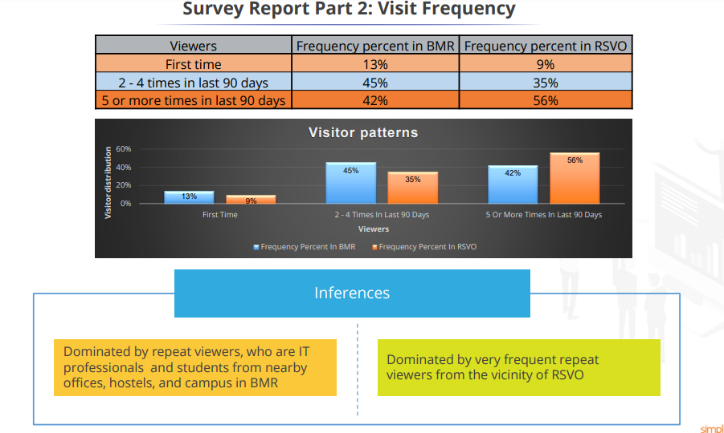

## RMT Booking Pattern

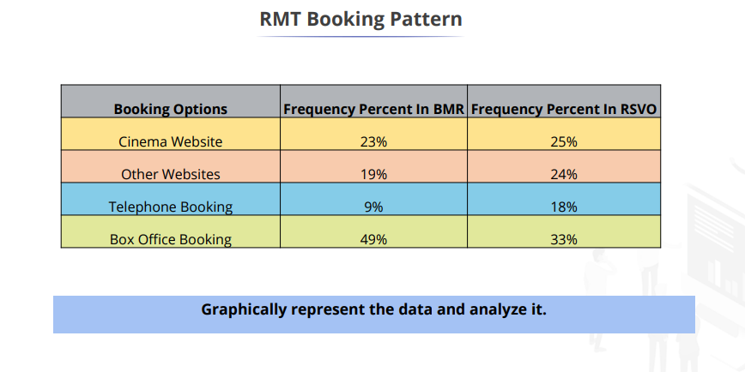

Graph : Booking pattern at RSVO

Graph : Booking pattern at BMR

|  |  |
| --- | --- |
| Inferences | |
| In BMR, viewers prefer box office purchases with no additional cost to the tickets. | Viewers prefer online purchases and are willing to pay additional convenience charges at RSVO. |

* **Phone booking is comparatively low in both places.**

## Theater Experience

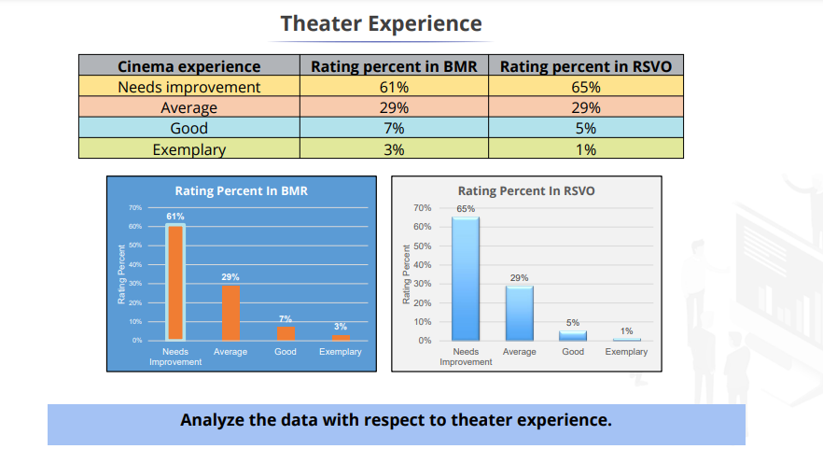

**Inference:**

* **Viewers are not happy with the cinema experience at RMT (both BMR and RSVO)**
* **It is very evident in both locations that it needs improvement. Only a few percentages of people feel it is good and exemplary.**

### Theatre Hygiene experience

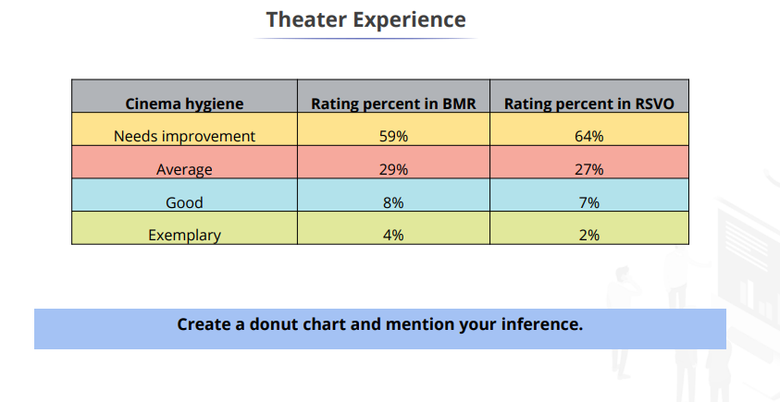

Graph : Theatre Hygiene at RSVO

Graph : Theatre hygiene at BMR

**Inference:**

* **Viewers are facing issues with the cinema hygiene at RMT (both at BMR and RSVO)**
* **Very few percentages of the crowd say that locations are good and exemplary.**
* **It is observed more than 50% of the crowd voted for the need for improvements.**
* **It is evident that both locations need to work on their hygiene immediately or would lose a lot of customers.**

### Theatre F and B Experience:

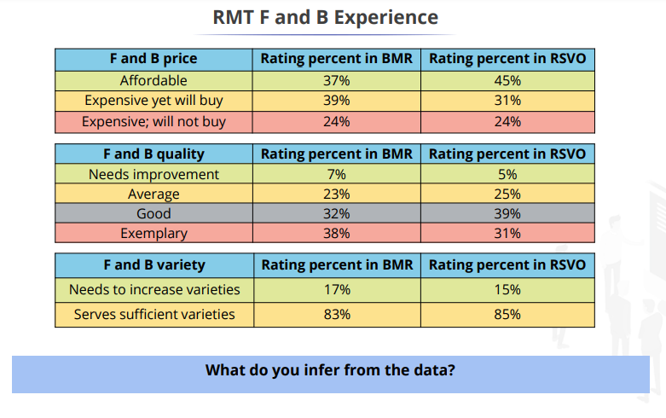

**Inferences on Food and Beverages:**

* **Pricing experience: The majority of the crowd feels it is affordable and expensive yet will buy and of course, some feel it is expensive and will not buy in both locations.**
* **Quality experience: The majority of the crowd is happy with the quality. Very few feel it needs improvements.**
* **Variety experience: The majority of the crowd agreed and was happy with the variety.**

## RMT Staff Performance

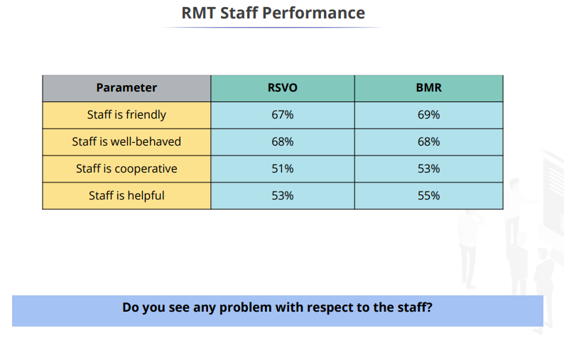

**Viewers are satisfied with the RMT staff (both at BMR and RSVO) but there is a scope for improvement.**

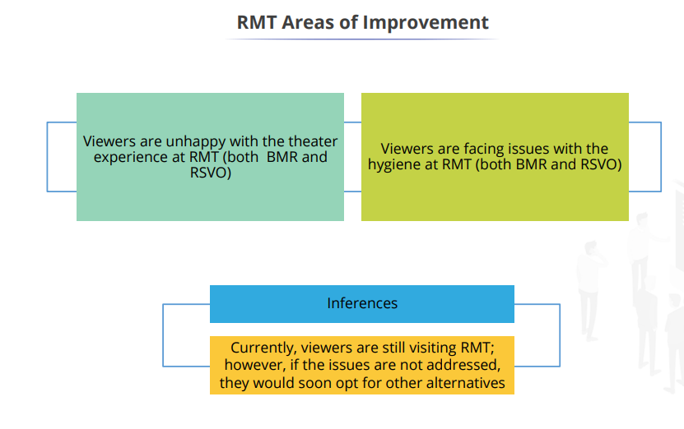

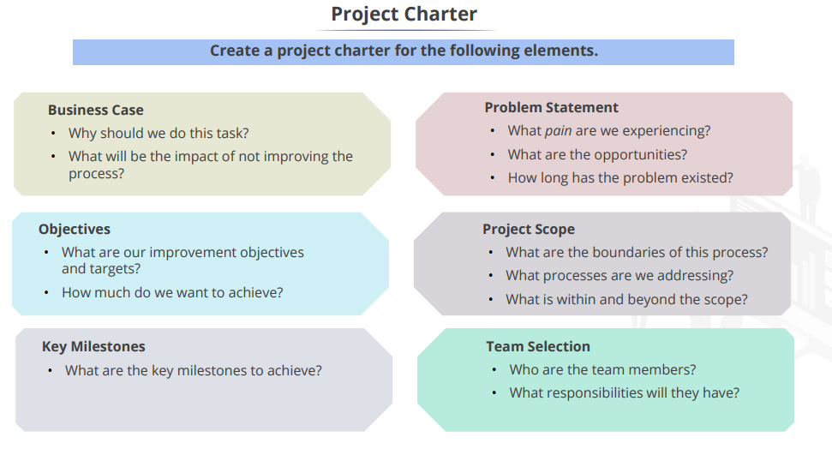

**RKM**

## Project Charter Document

**Project Name: Rexon Movie Theatre**



**PROJECT CHARTER PURPOSE:**

The project needs to be done to reduce Overhead costs, vide printing course material and posting of course material to different cities in India and overseas are high. The approximate charge of printing per book is INR 1000/- and the approximate posting charge is INR 500/-.

**Problem Statement:**

* An overall average of 63% of viewers are dissatisfied with the RMT movie experience, and 62% are dissatisfied with RMT cinema hygiene.
* If the difficulties are not solved immediately, viewers will choose other options, reducing revenue and making it difficult for RMT to continue with the business in the following 6- 8 months.
* This could result in a shutdown or RMT being taken over by competitors.

**Objectives (Goal Statement):**

In the next 8 months, improve the RMT cinema experience for BMR and RSVO by 70% and RMT cinema hygiene by 85% in order to retain existing viewers and attract viewers from competition for increased profitability.

**Business Case:**

* If the RMT cinema experience and hygiene are not improved, competitors E2, AGP, and Frames will gain RMT market shares in the next 6-8 months, with the problem affecting existing RMT viewers by 50% more than the current condition, resulting in a 70% revenue drop by the end of the year.
* If RMT cinema experience and hygiene improve by 75% in the next 6-8 months, we will be able to retain current viewers while also gaining 15% of the growing market share due to increased brand value and better viewer experience and reviews, pushing revenue up by 20% in the next year.

**Project Scoping:**

To work on and improve RMT cinema experience and RMT cinema hygiene, which will improve viewer experience and aid in retaining existing viewers while boosting new viewers, hence enhancing total profitability for RMT for both BMR and RSVO.

**Prepared by** Rathish Kumar Manjunath

## RACI Model

|  |  |  |  |  |  |
| --- | --- | --- | --- | --- | --- |
| Team members | Define | Measure | Analyse | Improve | Control |
| Black belt | A | A | R/A | R/A | A |
| Process owner | C/I | C/I | C | C/I | A/I |
| Process manager | C | C | C | C | R/I |
| Green belt | R | R |  |  |  |
| Financial representative |  |  | I |  |  |

# MEASURE PHASE

## Fishbone diagram

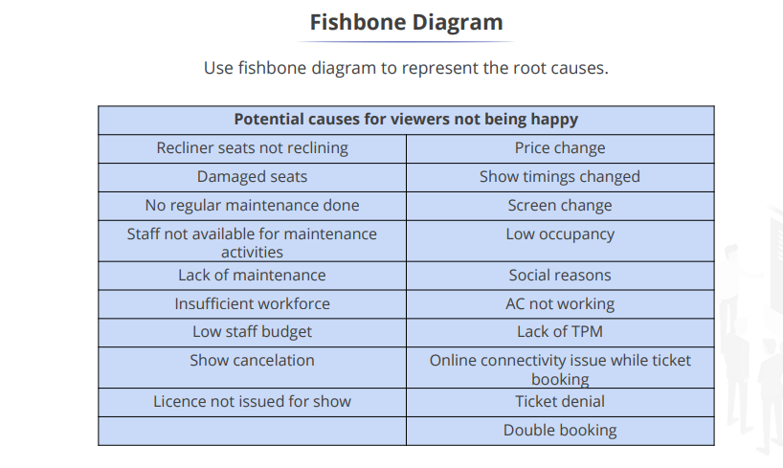

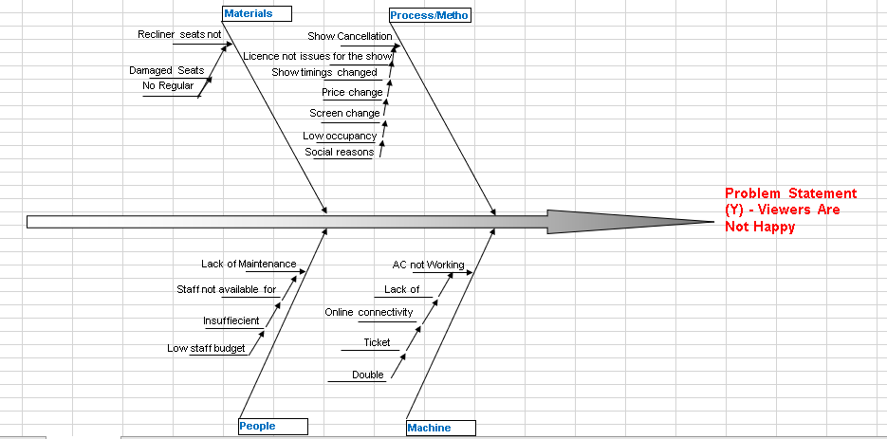

## Cinema viewers’ experience gander-based

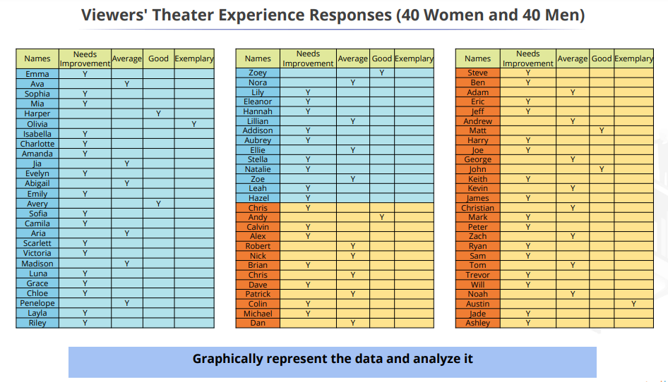

Graph : Cinema experience at RMT

**Women viewers are more uncomfortable with the RMT cinema experience than male viewers**

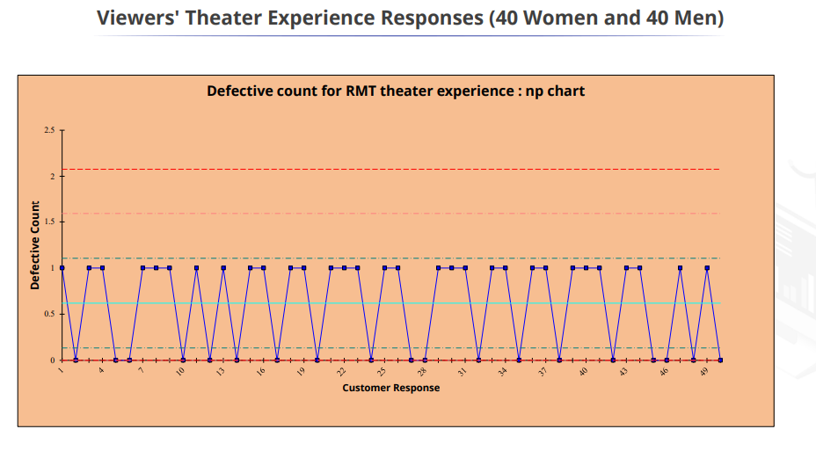

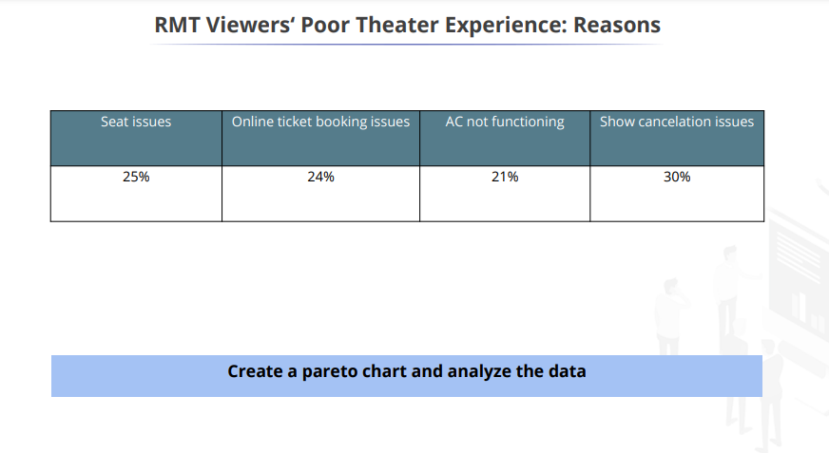

## Pareto chart

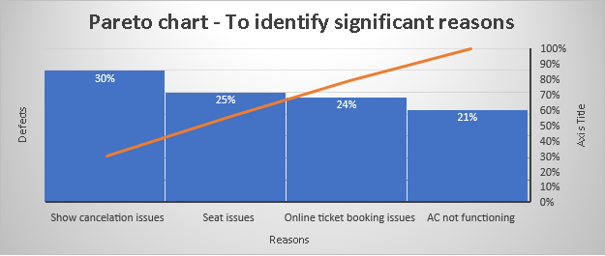

Graph : Pareto chart

**Observation:**

**Show cancellations are primarily the highest reason for poor theatre experience followed by seat issues, online booking issues and AC not functioning.**

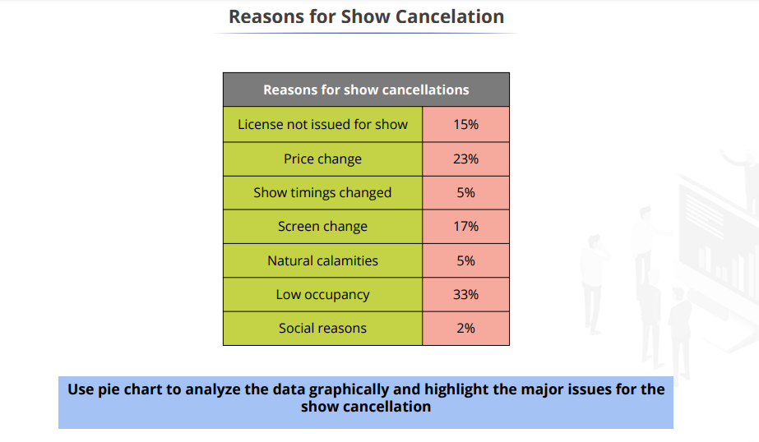

## Show cancellation reasons

Graph : Show cancellation reasons

**Observation:**

* **Majority of the show cancellation is because of the low occupancy by 33%.**
* **Price change and screen change are the second highest concerns.**

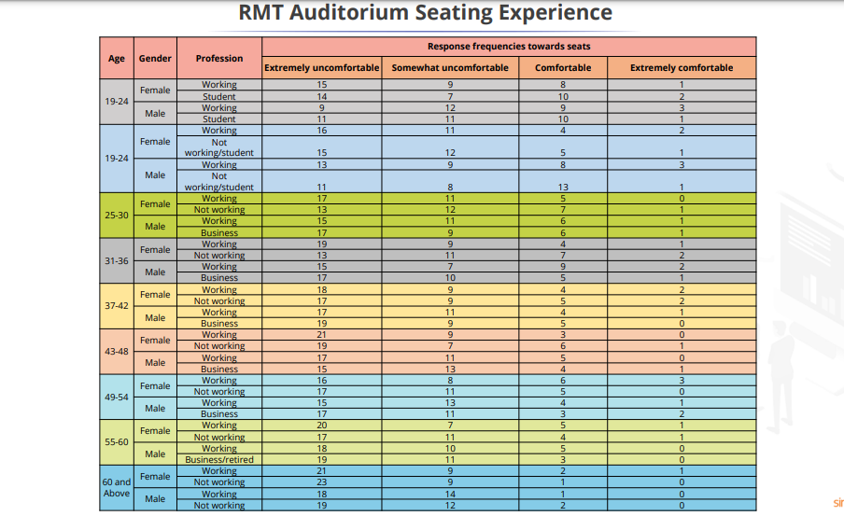

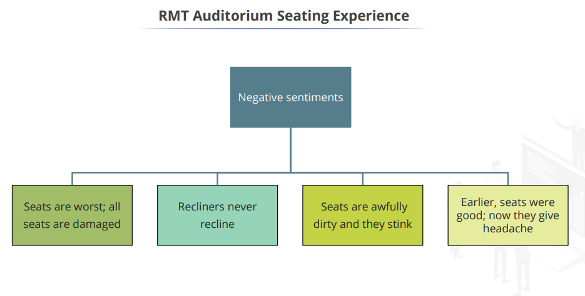

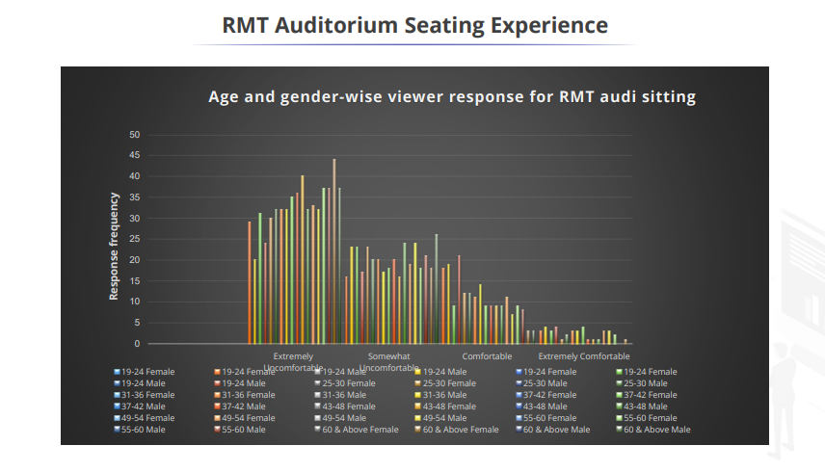

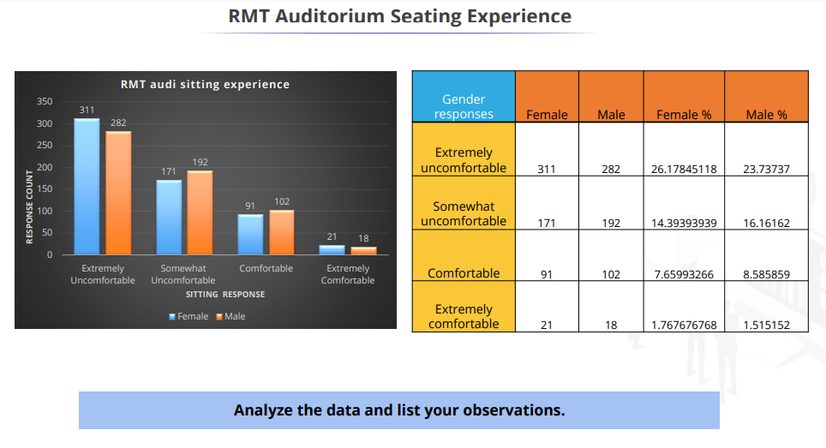

**Observations:**

* **26.17% of female viewers and 23.73% of male viewers are extremely uncomfortable with the RMT Audi sitting experience.**
* **26.17% of female viewers and 23.73% of male viewers are uncomfortable with the RMT Audi sitting experience.**

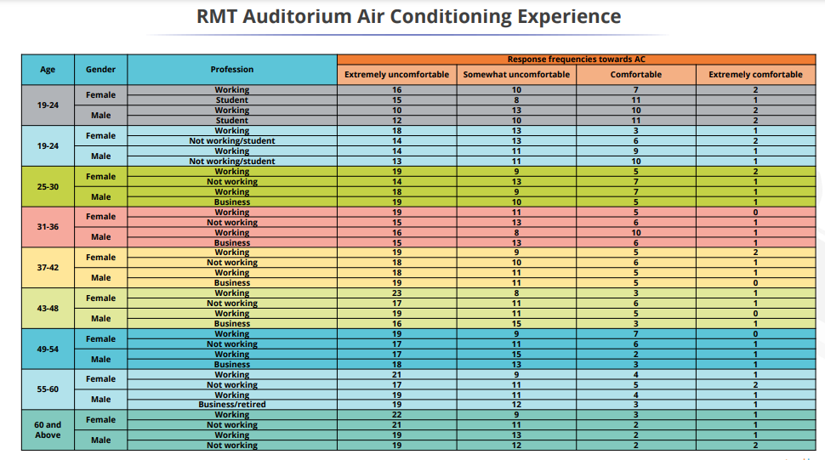

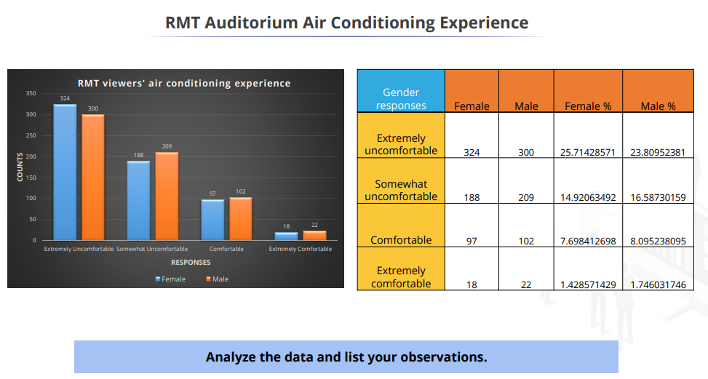

**Observations:**

* **25.71% of female viewers and 23.80% of male viewers are extremely uncomfortable with the RMT Audi AC experience.**
* **14.92% of female viewers and 16.58% of male viewers are uncomfortable with the RMT Audi AC experience**

## Cause and Effect Analysis

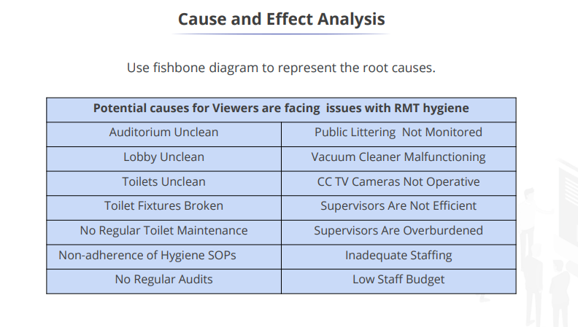

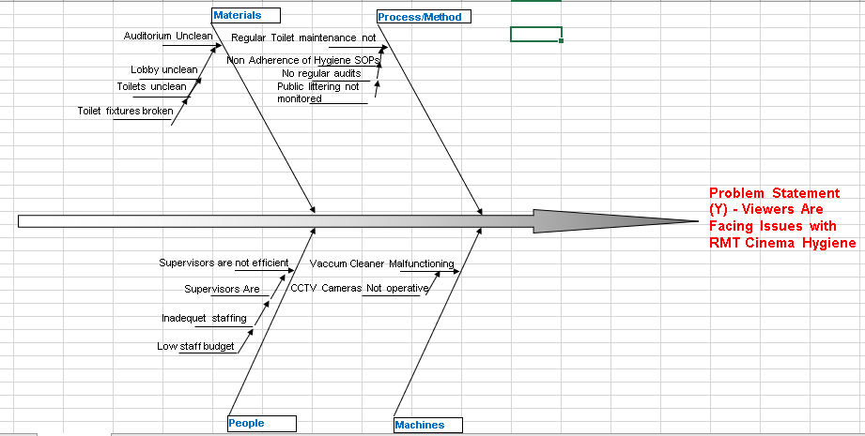

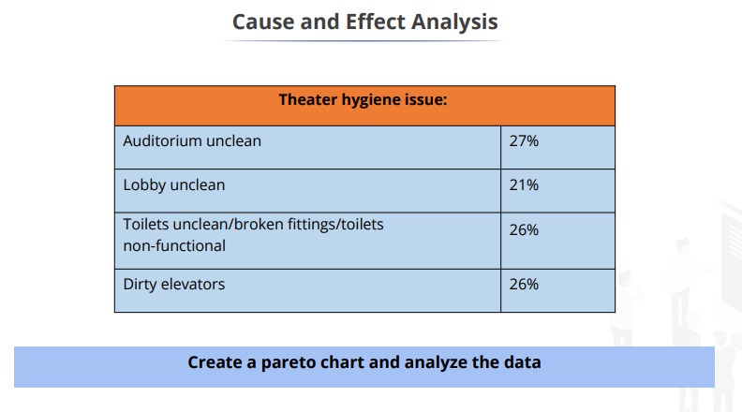

## Pareto Chart

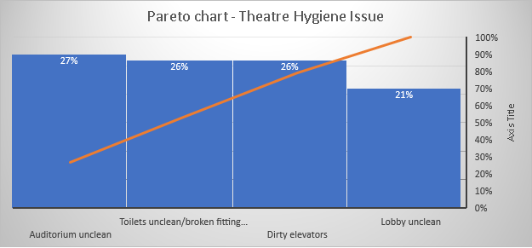

Graph : Pareto chart

**Observation:**

* **Hygiene is very crucial and a basic requirement for any facility.**
* **The majority of the crowd feels the facility has a lot of problems with cleanliness. This needs to be addressed and improved.**

## SIPOC

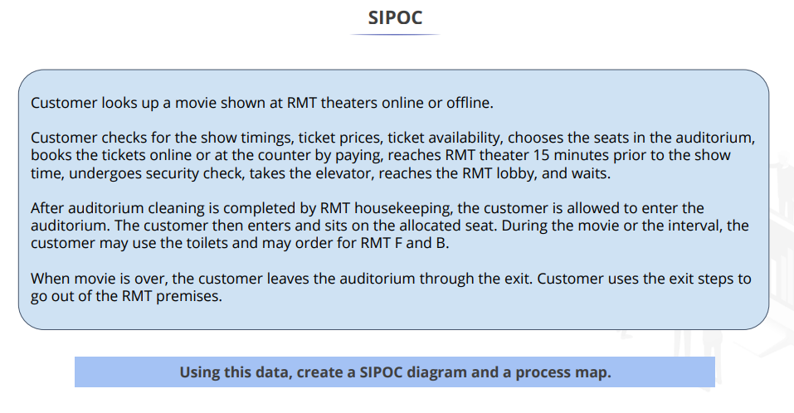

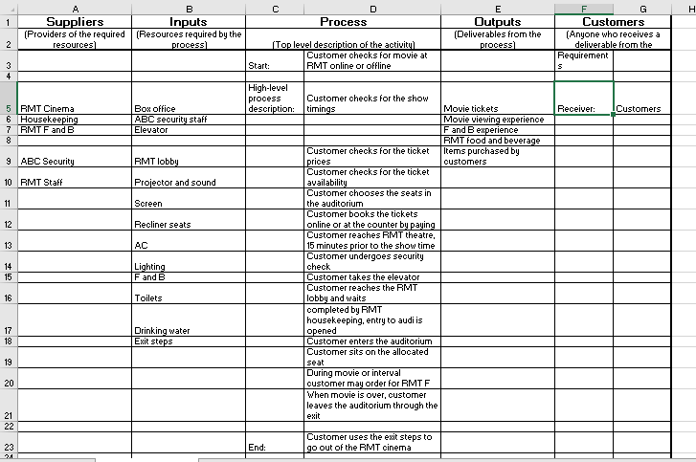

## Cause and Effect Matrix

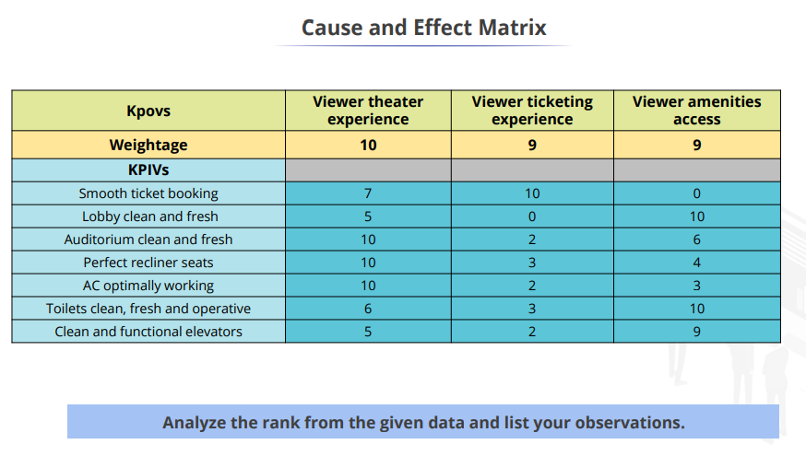

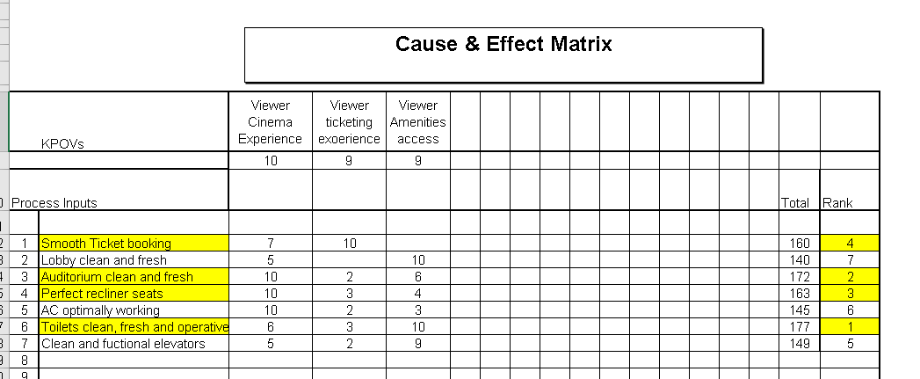

**Observation:**

* **The highest improvement area is the Toilets.**
* **Highlighted boxes are areas that should be prioritized for improvement.**

# ANALYZE PHASE:

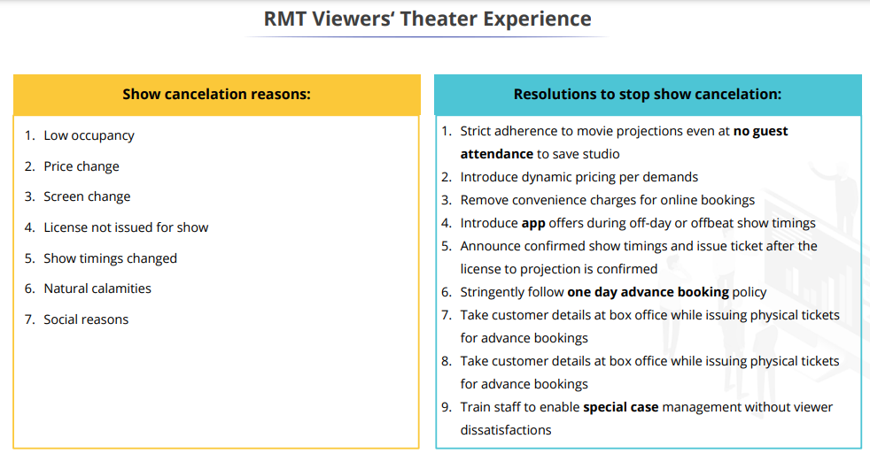

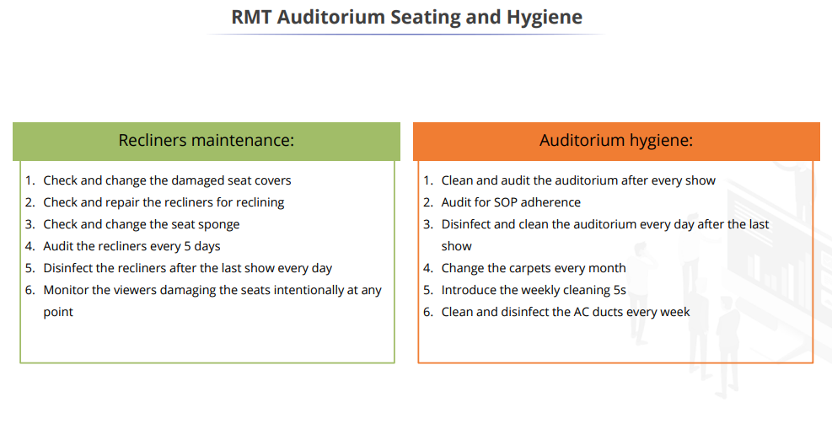

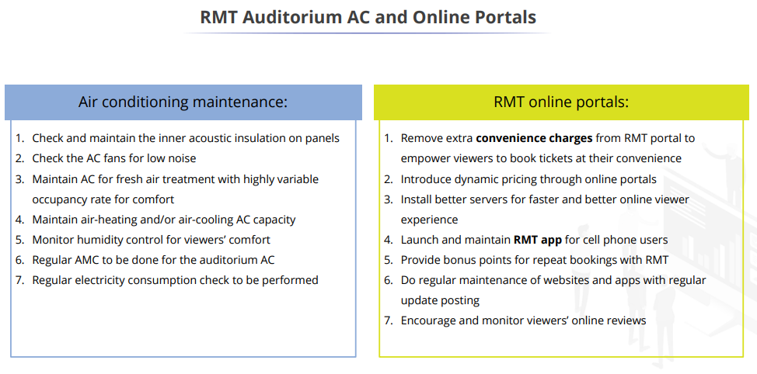

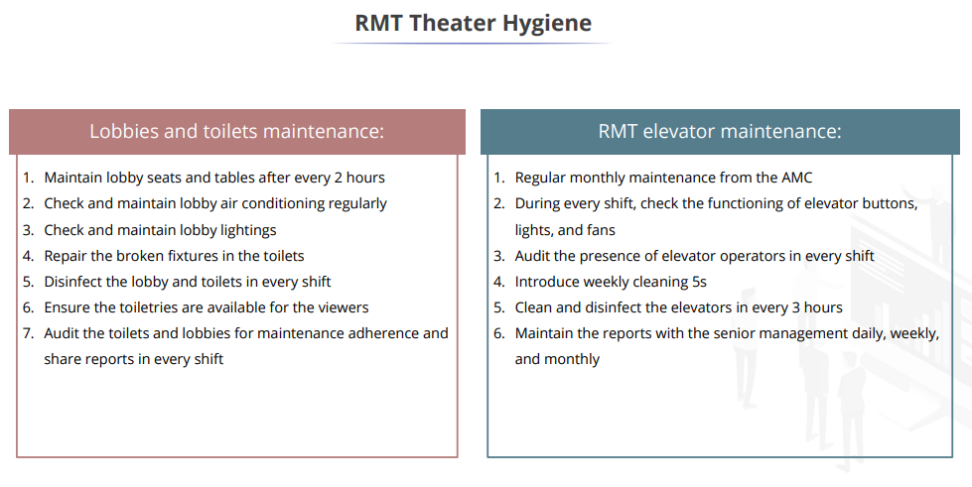

## RMT Audi Temperature Hypothesis Testing

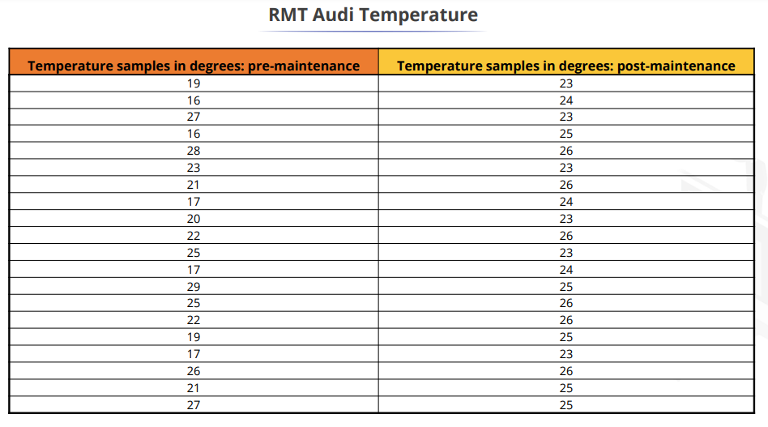

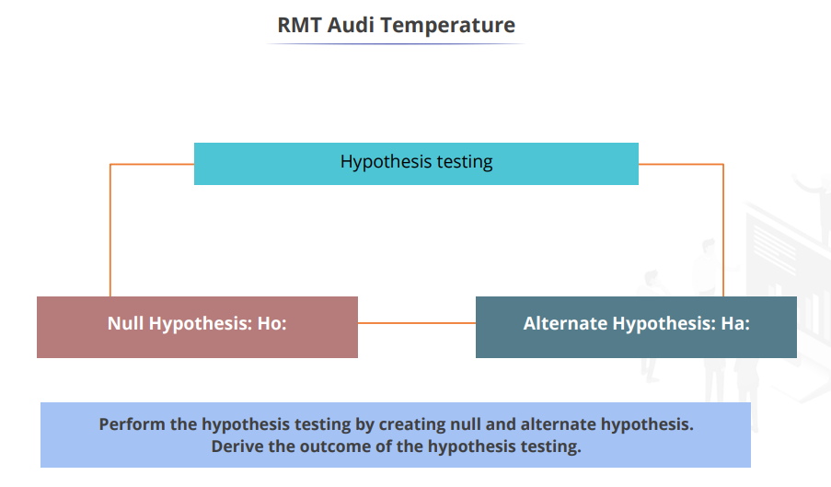

**Null Hypothesis (Ho): The Audi sample temperatures are similar, pre- and post-maintenance.**

**Alternate Hypothesis (Ha): The Audi sample temperatures are dis-similar, pre- and post-maintenance.**

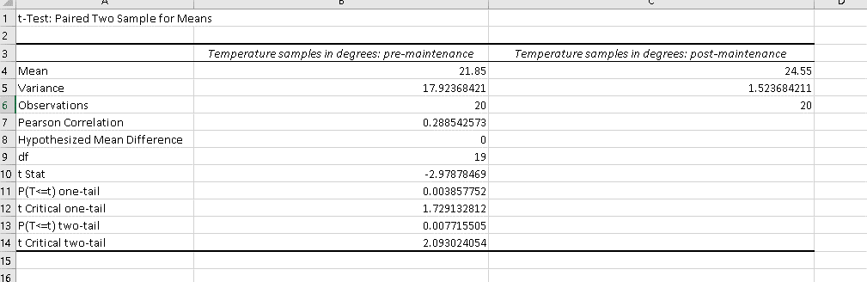

**Hypothesis testing:**

**P(T≤t) two tail = 0.007715505**

**The P value is less than 0.05 therefore the difference between the means is statistically significant. We will therefore reject the null hypothesis and conclude that there is a difference in the temperature pre- and post-maintenance.**

**Result: Reject Null Hypothesis**

**Alternate hypothesis (Ha): The Audi sample temperatures are dis-similar, pre- and post-maintenance.**

## RMT Audi Recliner Tilt Hypothesis Testing

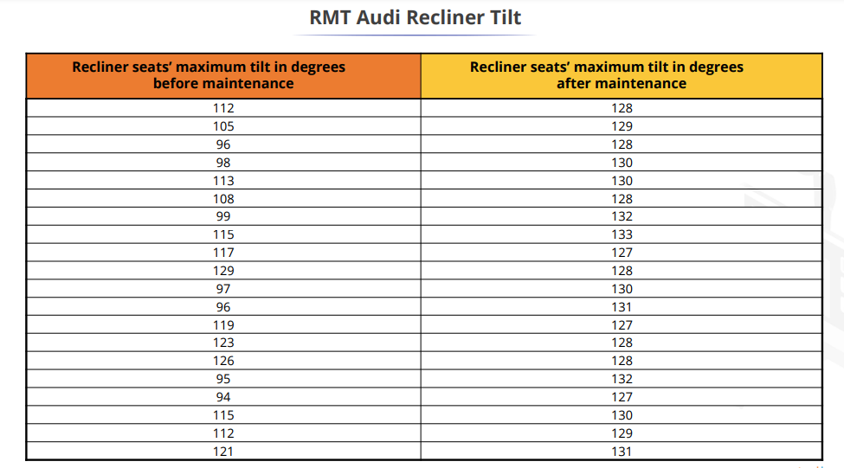

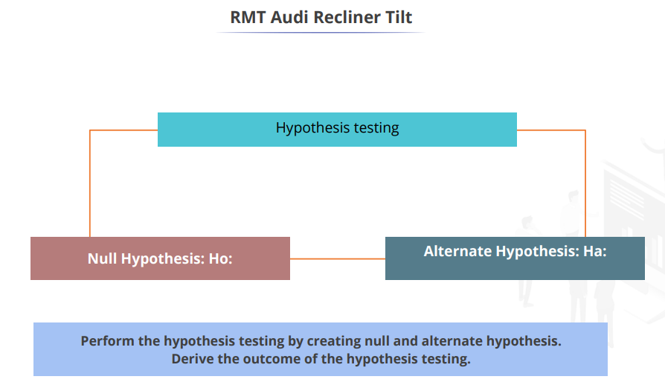

**Null Hypothesis (Ho): The Audi recliners are reclining similarly, pre- and post-maintenance.**

**Alternate Hypothesis (Ha): The Audi recliners are reclining dis-similarly, pre- and post-maintenance.**

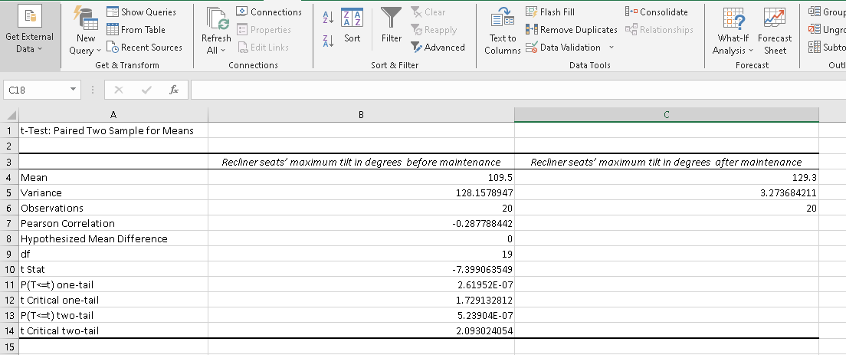

**Hypothesis testing:**

**P(T≤t) two tail = 0.000000523904**

**The P value is less than 0.05 therefore the difference between the means is statistically significant. We will therefore reject the null hypothesis and conclude that there is a difference in the reclining pre- and post-maintenance.**

**Result: Reject Null Hypothesis**

**Alternate hypothesis (Ha): The Audi recliners are reclining dis-similarly, pre- and post-maintenance.**

# IMPROVE PHASE:

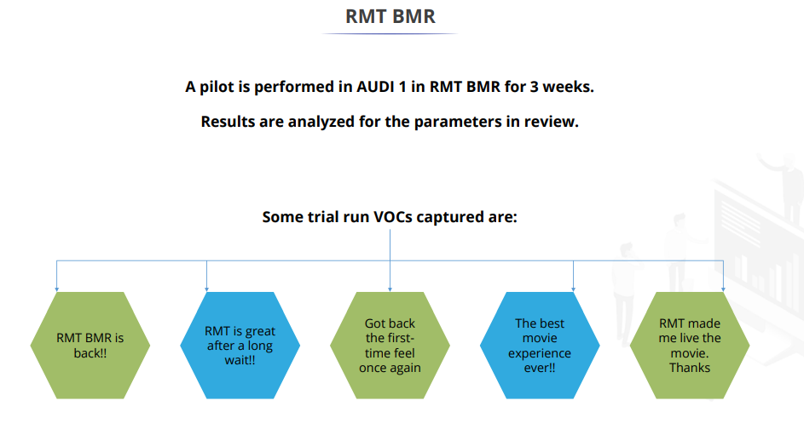

## RMT Audi Temperature Optimality Analysis Hypothesis Testing

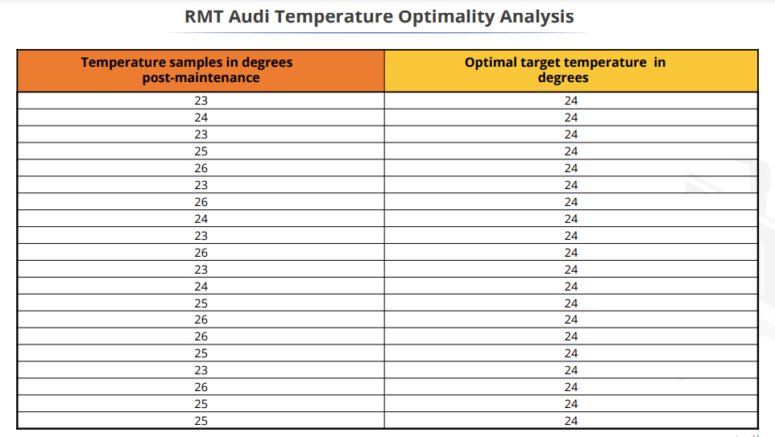

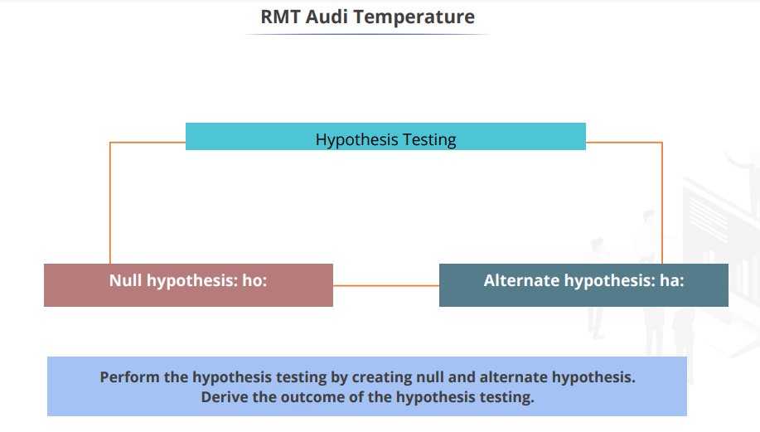

**Null Hypothesis (Ho): The Audi sample temperatures are similar to the optimal target temperature.**

**Alternate Hypothesis (Ha): The Audi sample temperatures are dis-similar to the optimal target temperature.**

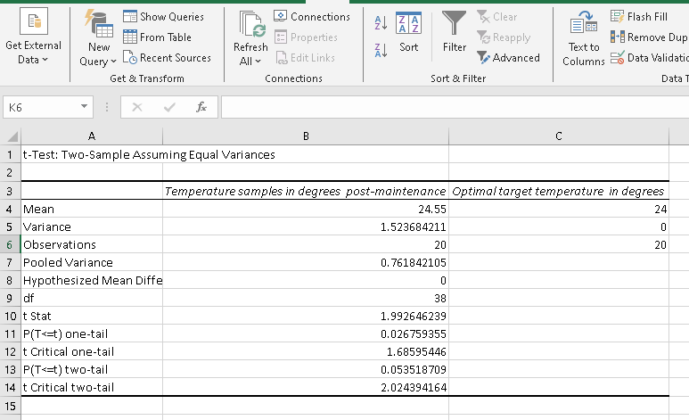

**Hypothesis testing:**

**P(T≤t) two tail = 0.0053519**

**The P value is greater than 0.05 therefore the difference between the means is not statistically significant. We therefore cannot reject the null hypothesis. We can conclude the observed difference may be due to the common cause variation.**

**Outcome: Accept the null hypothesis**

**Null hypothesis (Ho): The Audi sample temperatures are similar to the optimal target temperature.**

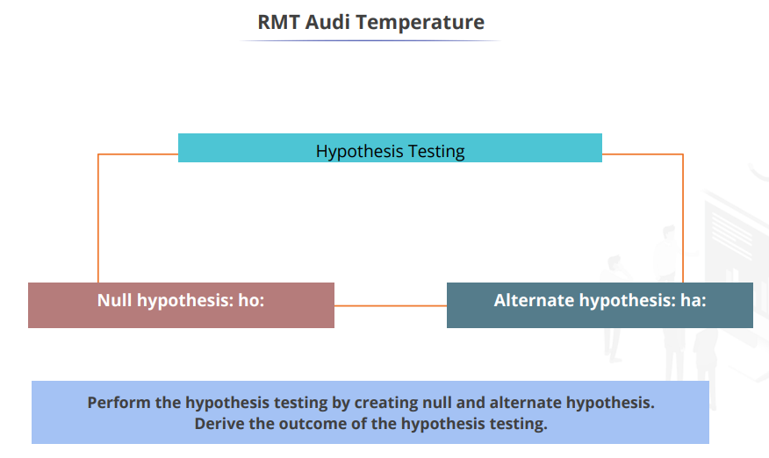

**Null Hypothesis (Ho): The Audi recliners are reclining as per the target.**

**Alternate Hypothesis (Ha): The Audi recliners are not reclining as per the target**

## RMT Audi Recliner Tilt Goodness Analysis Hypothesis Testing

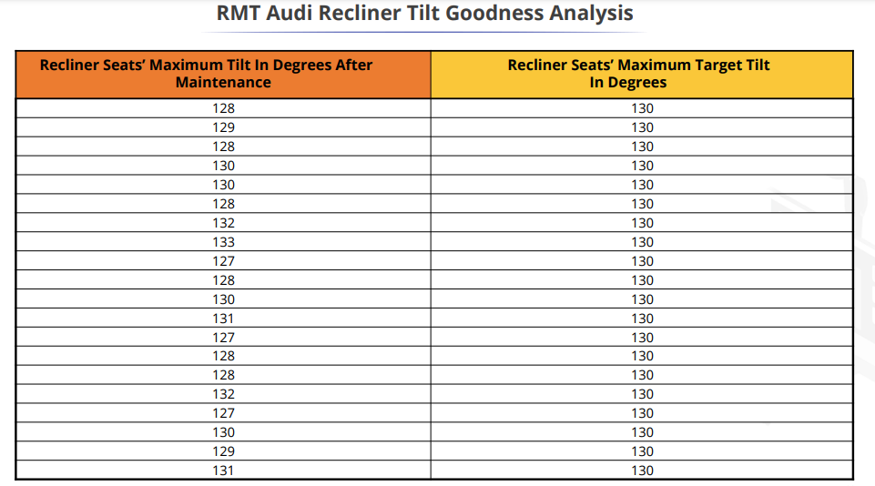

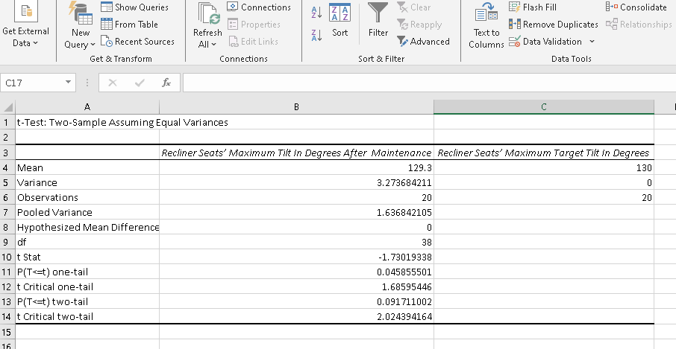

**Hypothesis testing:**

**P(T≤t) two tail = 0.0053519**

**The P value is greater than 0.05 therefore the difference between the means is not statistically significant. We therefore cannot eject the null hypothesis. We can conclude the observed difference may be due to the common cause variation.**

**Outcome: Accept the null hypothesis**

**Null Hypothesis (Ho): The Audi recliners are reclining as per the target**

## RMT Audi Temperature PRE and Post Improvement

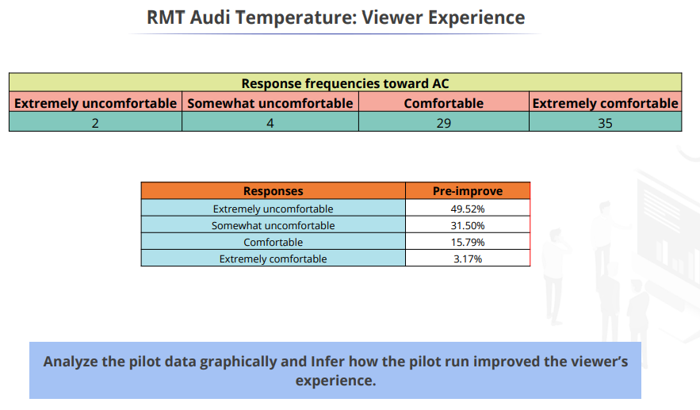

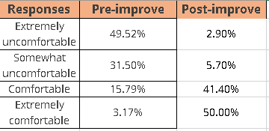

Graph : Air Conditioning after pilot test

**Observation:**

* **Based on the measure taken to improve the viewers' experience and upon hypothesis testing we can conclude that there is a good improvement in the viewers' experience.**
* **50% of the customers are extremely comfortable post improvements.**

## RMT Viewers’ Theatre Experience

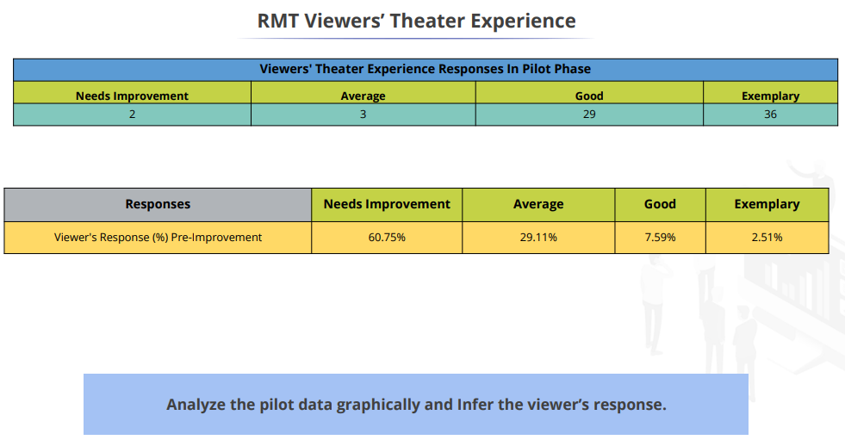

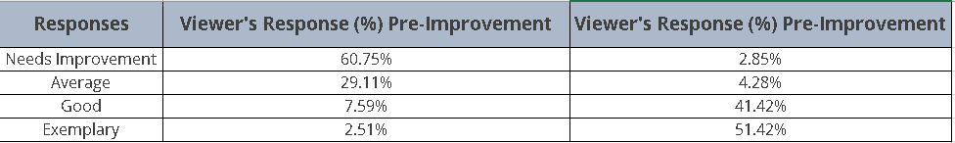

Graph : Theatre experience after pilot test

**Observation:**

**Based on the measure taken to improve the viewers' experience and upon hypothesis testing we can conclude that there is a good improvement in the viewers' experience.**

**51% of the customers are extremely comfortable post improvements.**

# CONTROL PHASE:

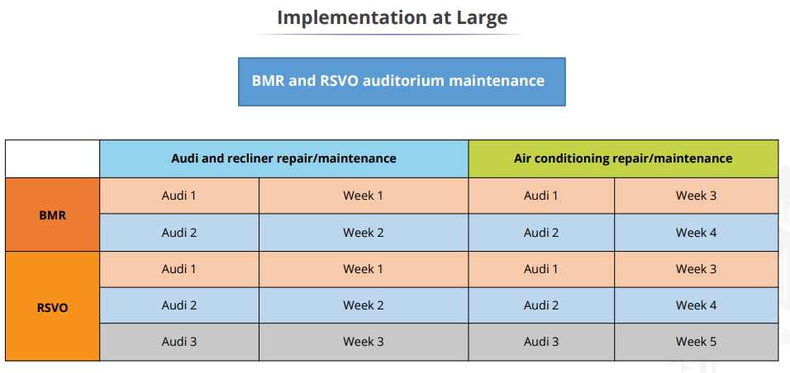

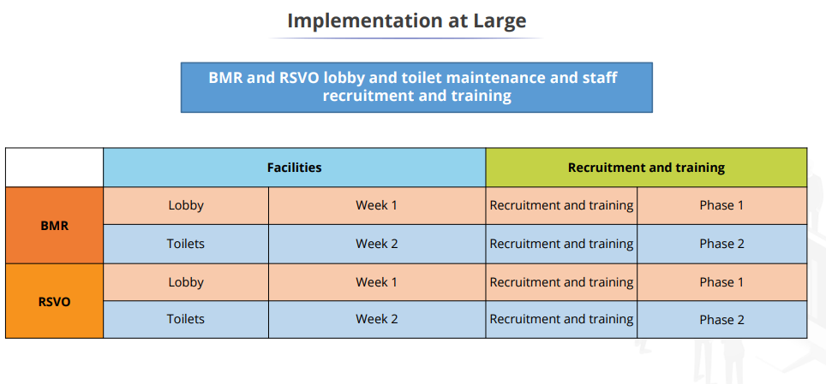

## Inferences:

* **Based on the VOC we have identified the issues with the RMT theatres at both locations.**
* **VOC of different categories were collected based on different areas to understand the problems better and to identify the areas for opportunities.**
* **A series of measures such as a SIPOC was done to understand the process. Fishbone diagram to identify the issues (cause and effect analysis).c Cause and Effect matrix to identify the main causes of the issues and their impact on business have been taken to identify the core reasons for customer dissatisfaction.**
* **Basis which it was observed, the majority of the issues were due to Hygiene and Maintenance.**
* **A suitable resolution was used to resolve the problems identified.**
* **Upon Hypothesis test conducted on recline tilt and AC temperature, it was observed that there was a major response of improvement in customer satisfaction and Experience.**

## Conclusion:

* **The importance of Improving Rexon Movie theatre experience to attract more audience.**
* **Analyzed the data to decrease variation in a procedure for specific tasks.**
* **RMT cinema experience and the RMT cinema hygiene are improved.**
* **Worked on and brought improvement on RMT cinema experience and RMT cinema hygiene which will enhance viewer experience and help to retain the existing viewer base and increase the new viewers increasing overall profitability for RMT for both BMR and RSVO.**
* **Due to the sizeable scope, even a typically minor improvement in the sigma estimation of the method may significantly lower the perceived imperfection value, boost customer loyalty, and supply financial benefits to the main concern.**
* **It is possible to achieve fundamental improvements in expenses by cutting unnecessary activities. Also, by focusing on cutting waste, deciding the actual value of exercises, and using the DMAIC framework of Lean Six Sigma for critical thinking.**
* **Except for a few other analytical tools, this study has only used a limited amount of the Lean Six Sigma toolkit's resources.**